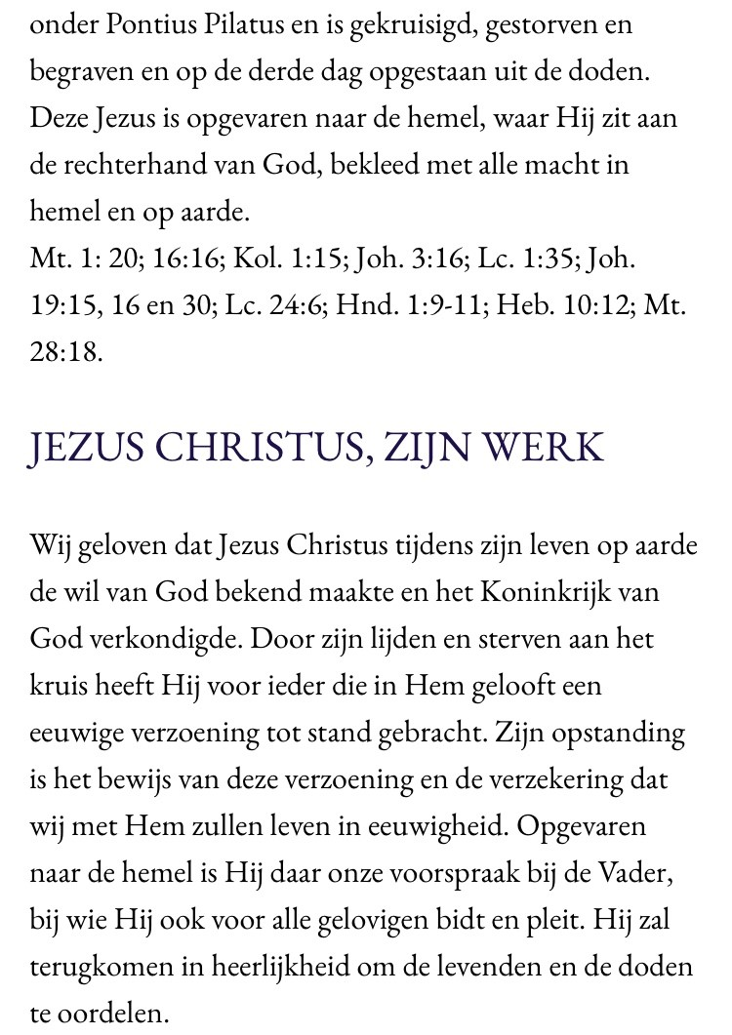

Jesus Christ Living Word Church
Page 3

