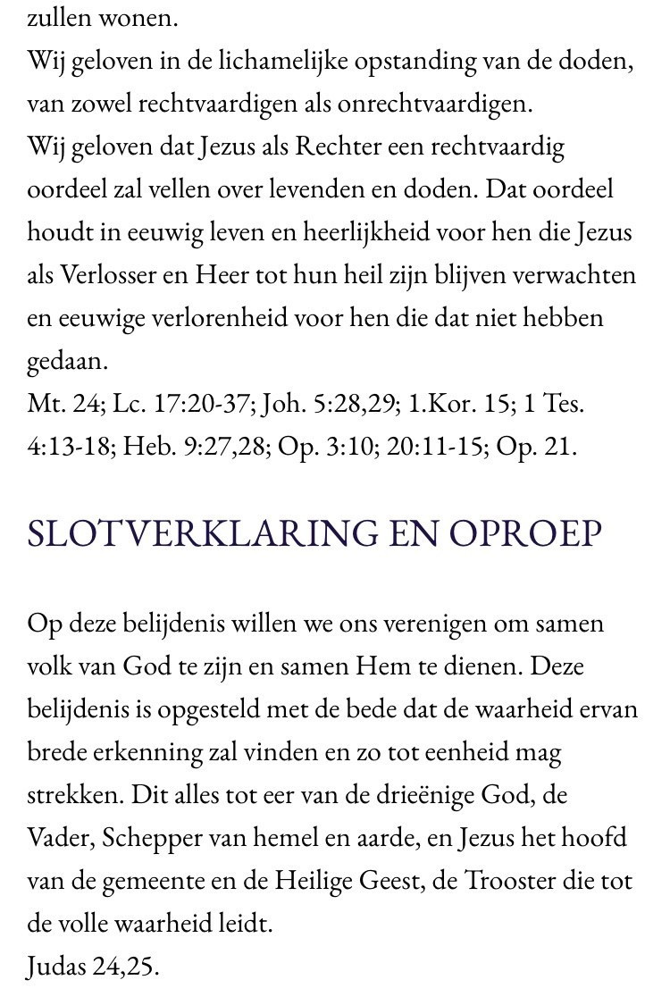

Jesus Christ Living Word Church

Page 10